The creation process of an **AWS account.**

Access the [AWS website](https://aws.amazon.com/).

Click on the button on the top right **Create an AWS Account.**

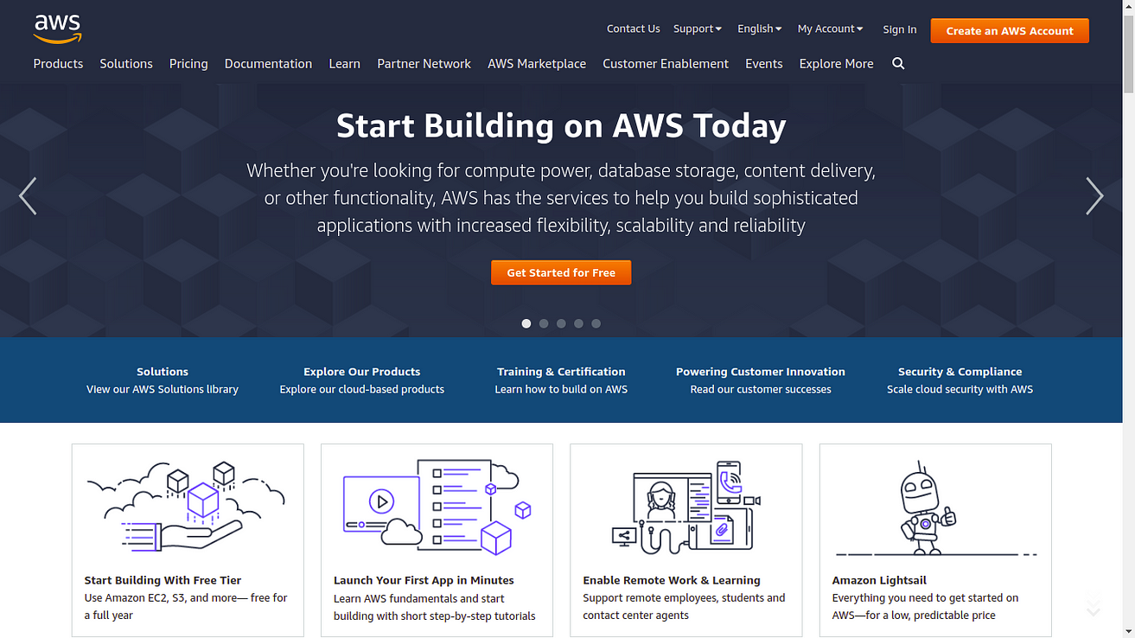

Amazon Web Services page

Enter the valid required details like Email address, Password and AWS account name.Then click **verify email address**.

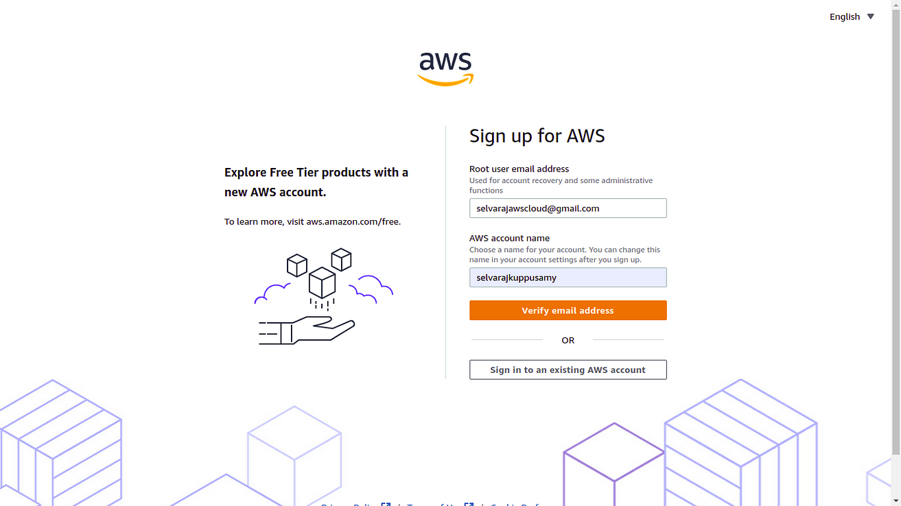

Sign up for AWS

Check respective email.After receiving verification code,to copy the verification code.

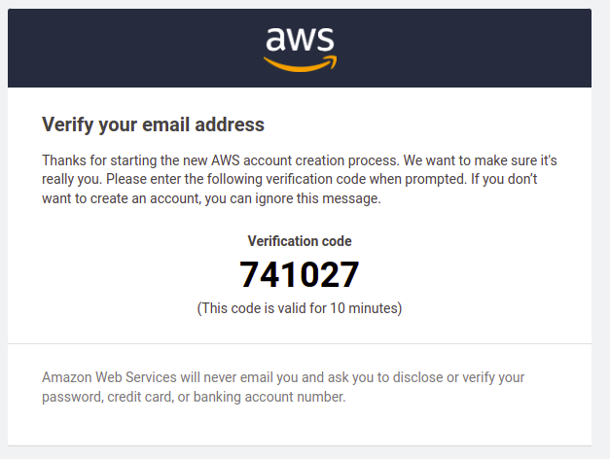

Verification code from email

Fill the verification code and Click **Verify**.

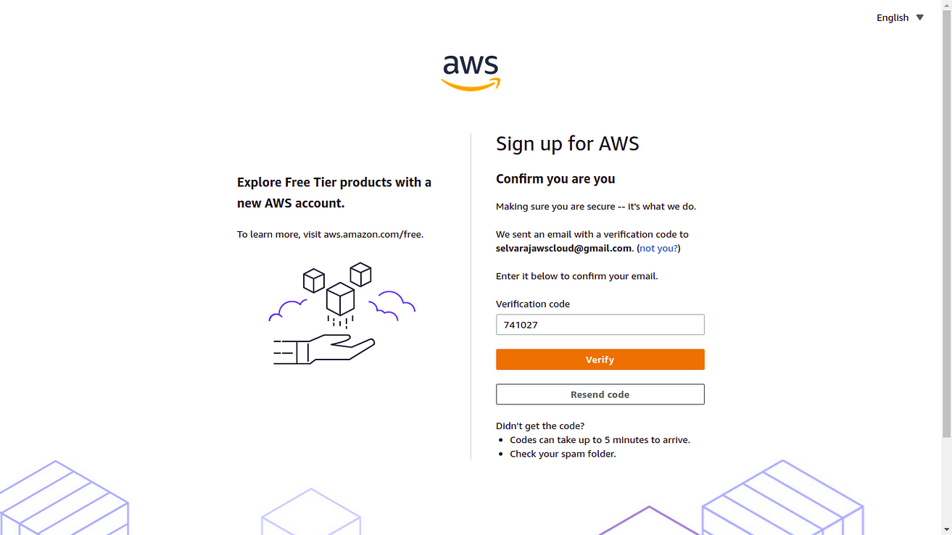

Sign up of AWS

Email address has been successfully registered. Then set Root user password. Then **Continue.**

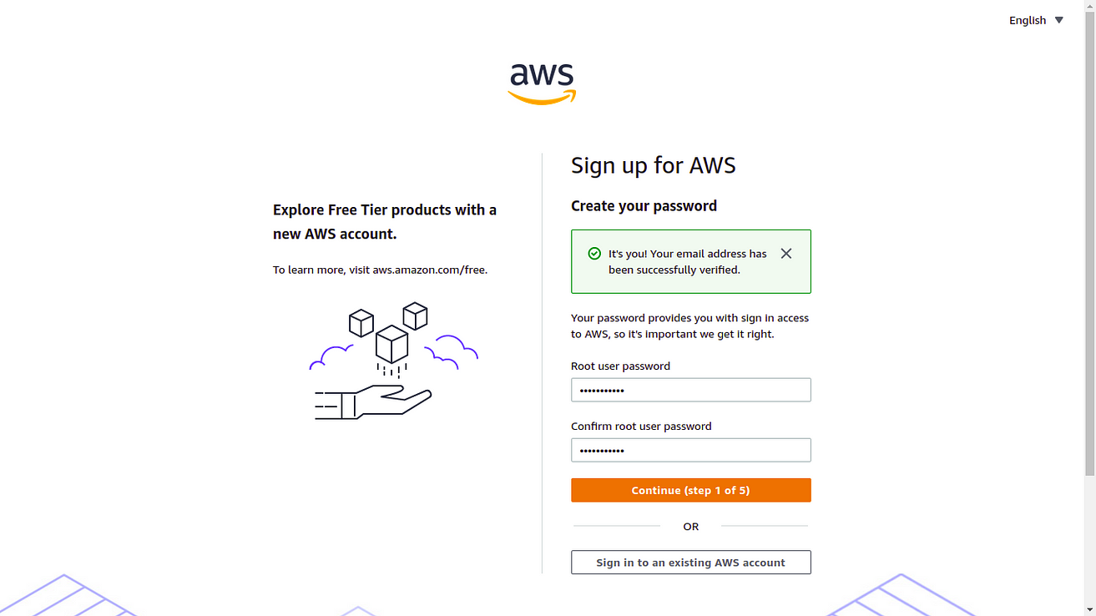

Sign up of AWS

Now, the registration process will ask you Personal information

Please select personal type account

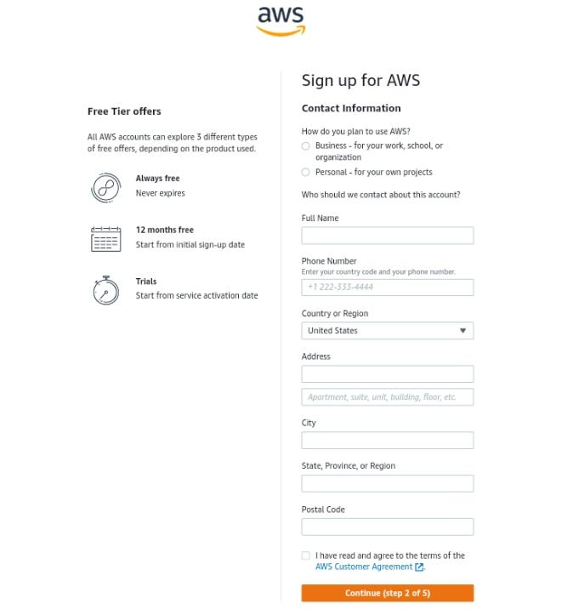

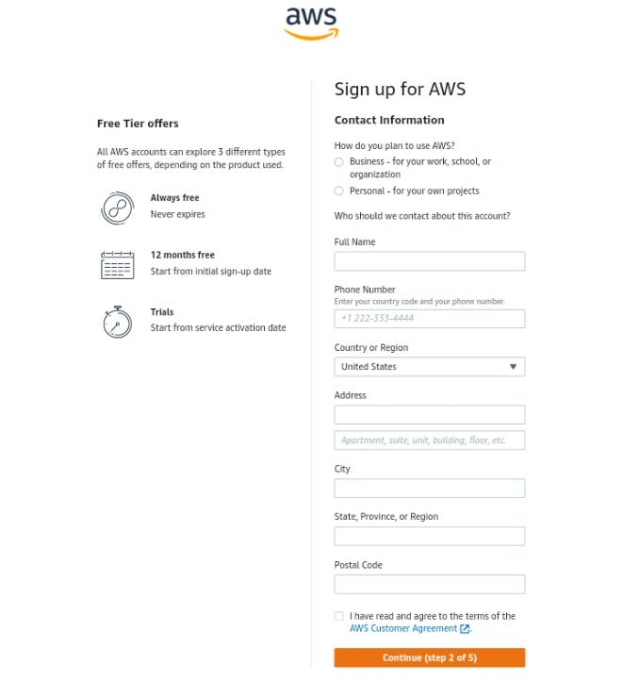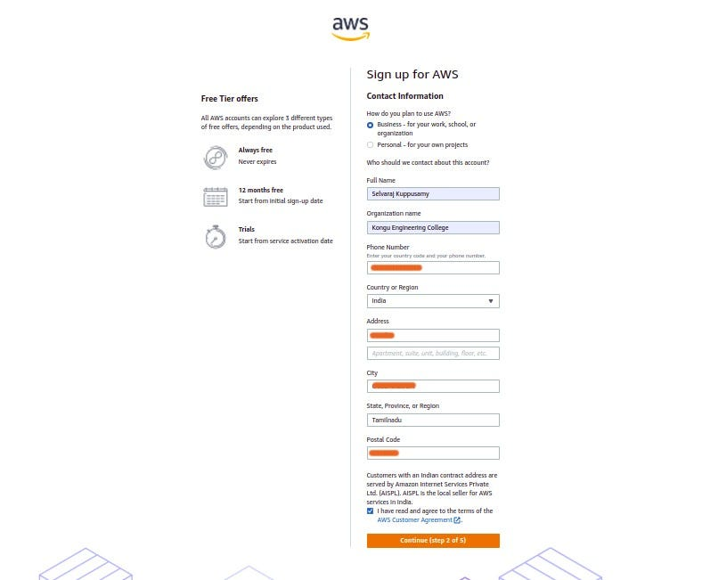

Sign up of AWS

Now, you will provide your payment information. Don’t worry about charges right now.

According to AWS: Please type your payment information so, we can verify your identity. We will not charge you unless your usage exceeds the [AWS Free Tier Limits](https://aws.amazon.com/free/)

In fact, depending on your credit card or debit card company, may be AWS could charge you about **2/-** to check if it is a valid credit card or debit card. They usually undo this charge later.

Click **verify and continue.**

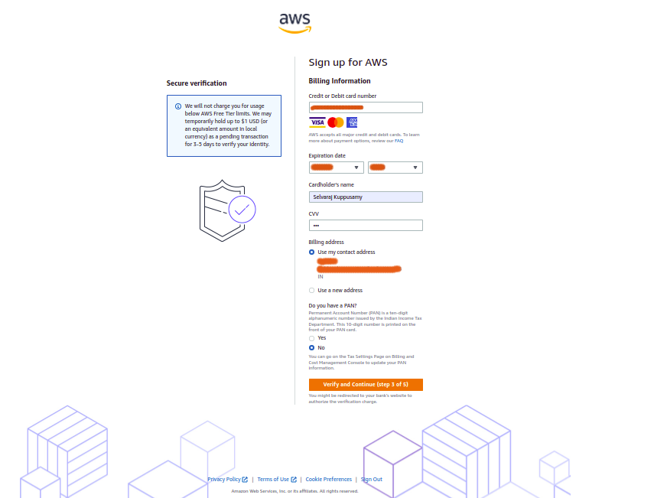

Sign up of AWS

Processing the payment process.

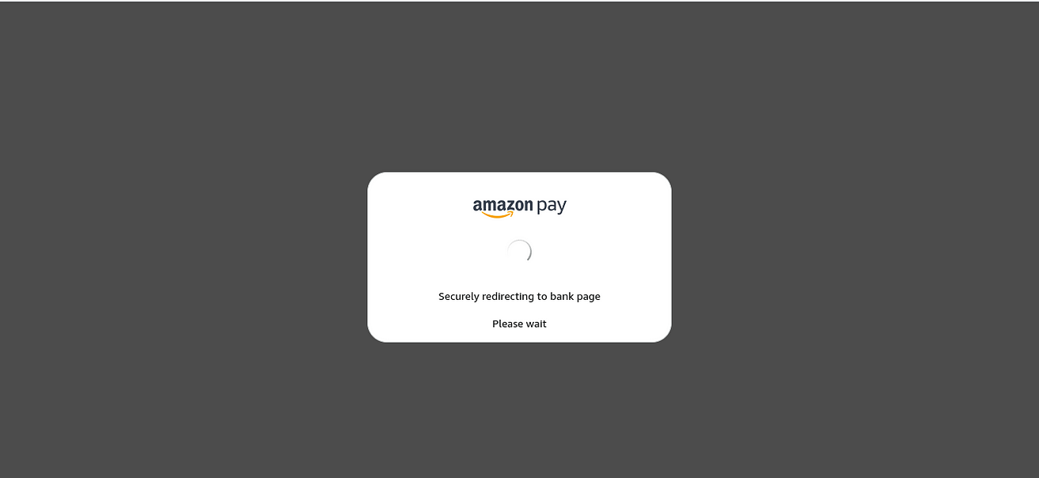

payment process

One Time Password will send the respective phone number.

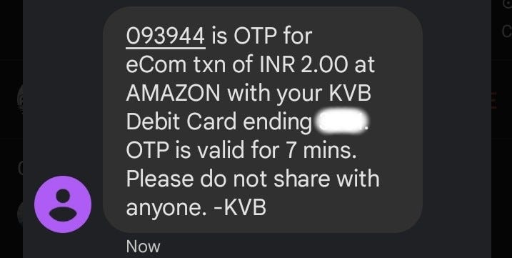

One Time Password from phone

Now, Enter the one time password in respective **bank**page. and then submit.

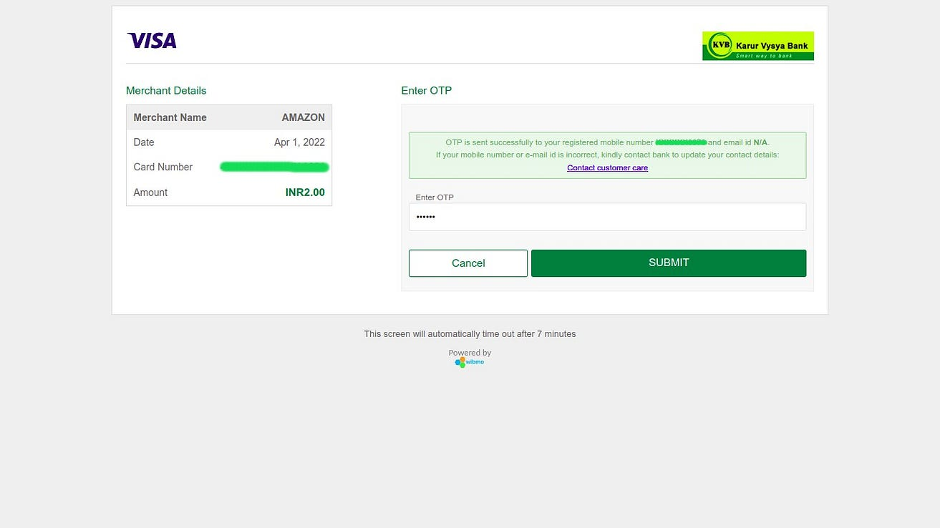

Payment Confirmation

Now you have to confirm your identity to activate your account. You can choose an Text message(SMS) or a Voice call to receive the verification code.And also presented with a CAPTCHA, enter the displayed code, and then **send**.

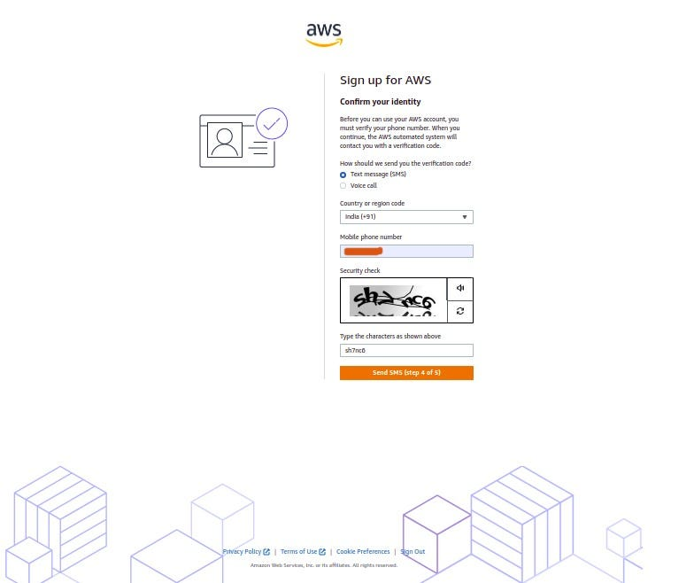

Sign up of AWS

Click on the **Send** button to continue.After the Verification send to Respective phone number.

In my case, I choose Text message(SMS). After receiving verification code,to copy the verification code.

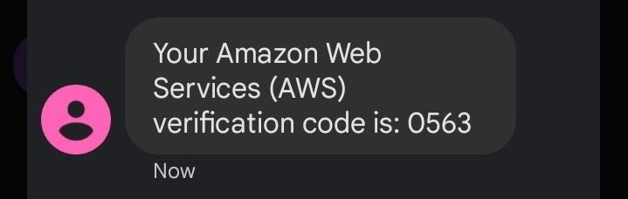

Verification code from phone

Fill the verification code and Click **Continue**.

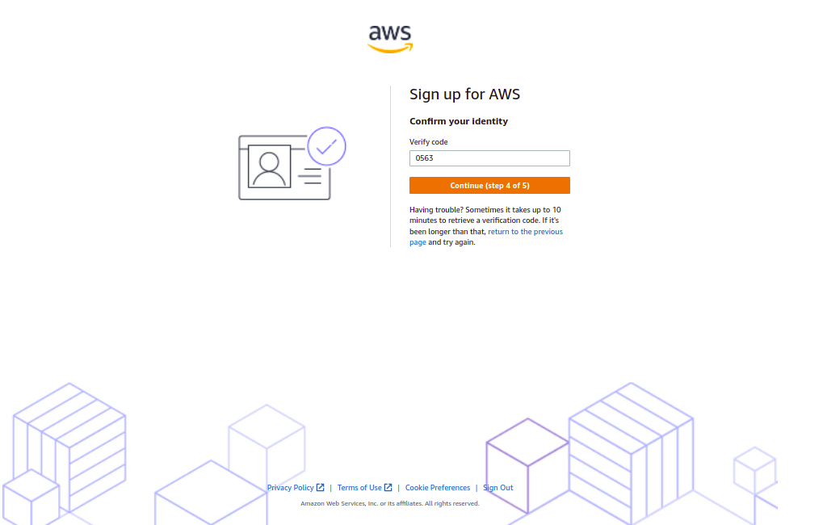

Sign up of AWS

On the Select a support plan page, choose one of the available Support plans.

You can start with the**Basic support - Free**. I strongly recommend reading about the Support Plans to be aware of what each one covers.

In my case, I choose **Basic support - Free.**

Then, Choose **Complete sign up**.

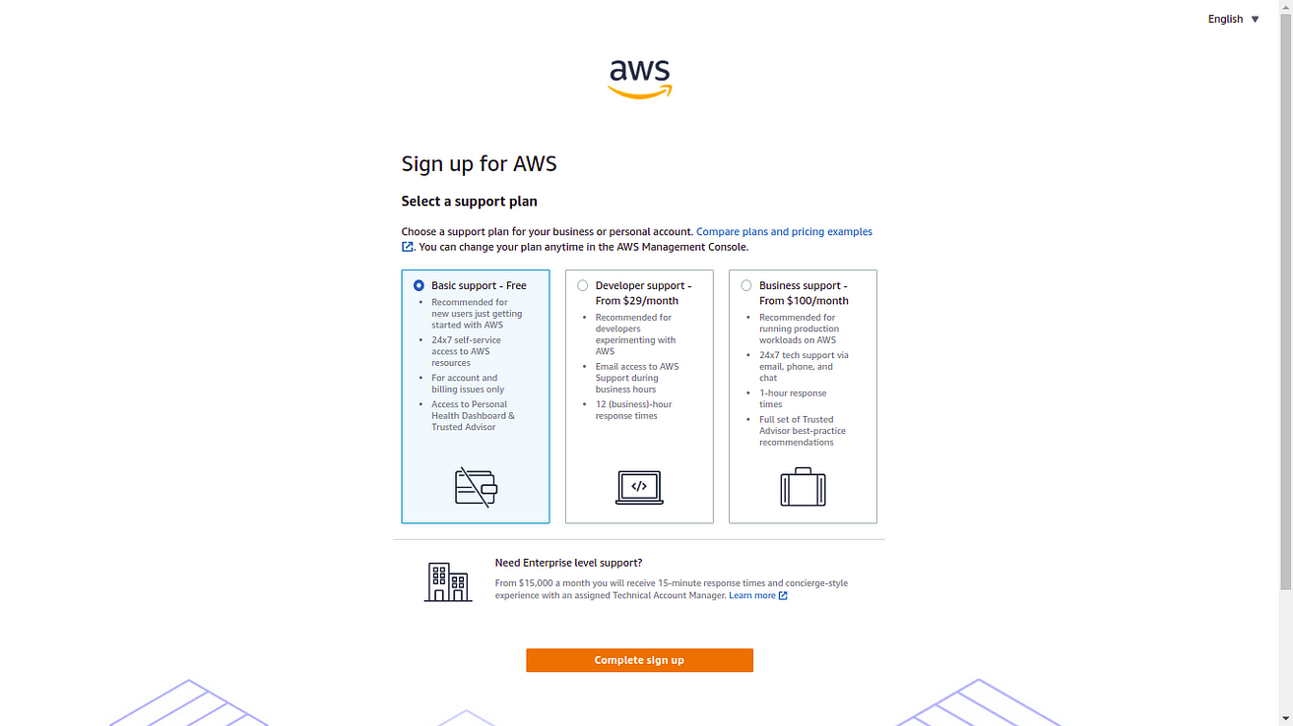

Sign up of AWS

**Amazon Web Services** account has successfully created. Click **Go to the AWS Management Console**.

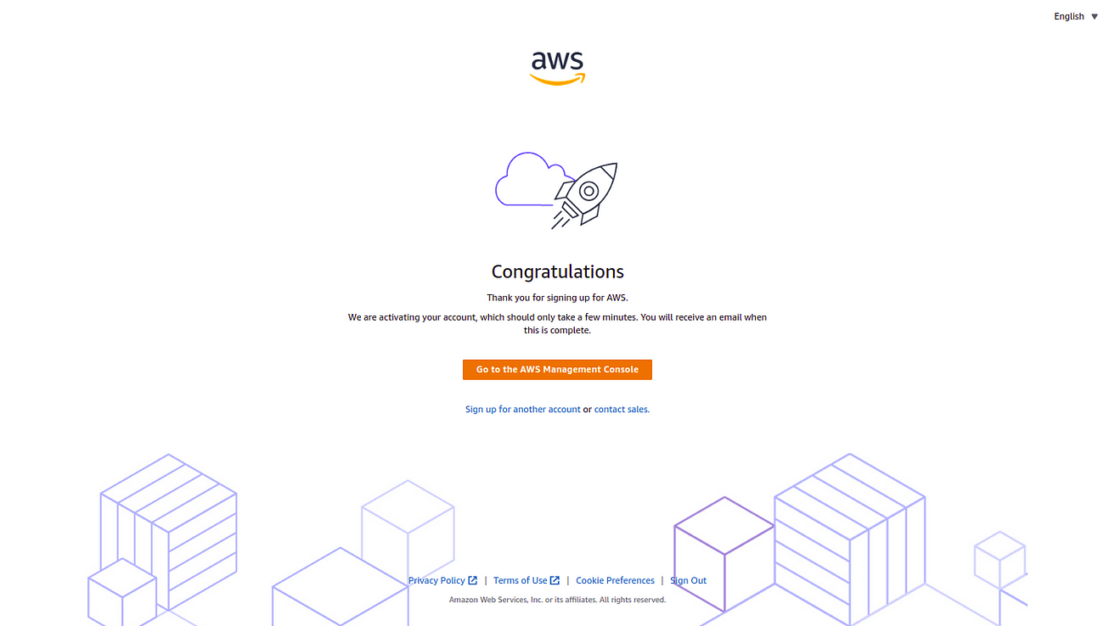

AWS account created page

Now, Enter your **Personalize Your Experience**. Click **Submit.**

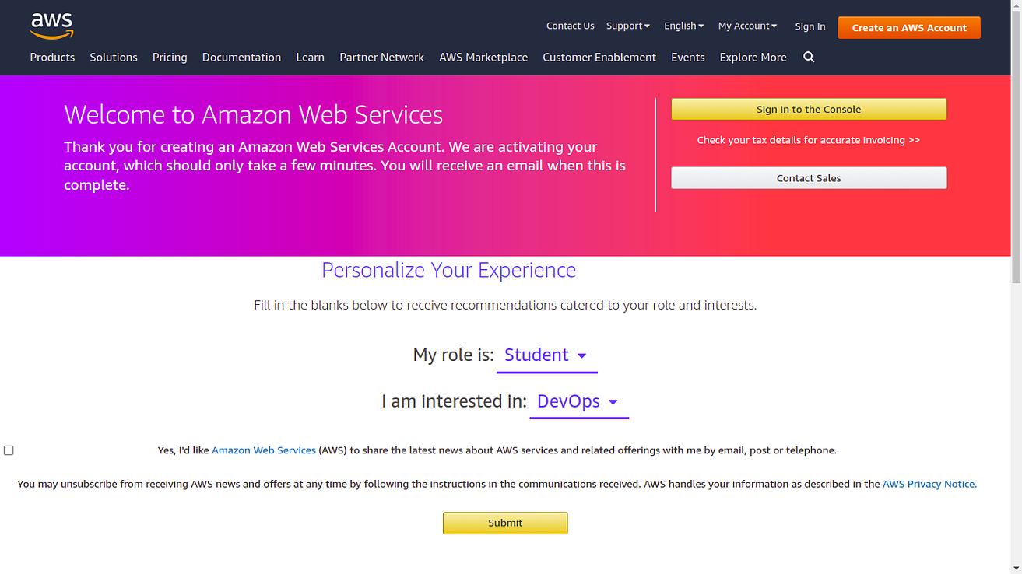

Amazon Web Services page

Click **Sign in to the Console.**

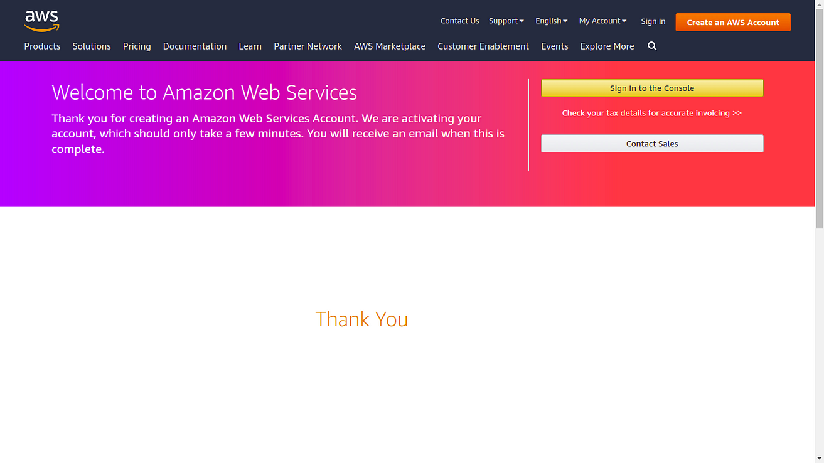

Amazon Web Services Page

Choose **Root user**and enter registered email and then click **Next.**

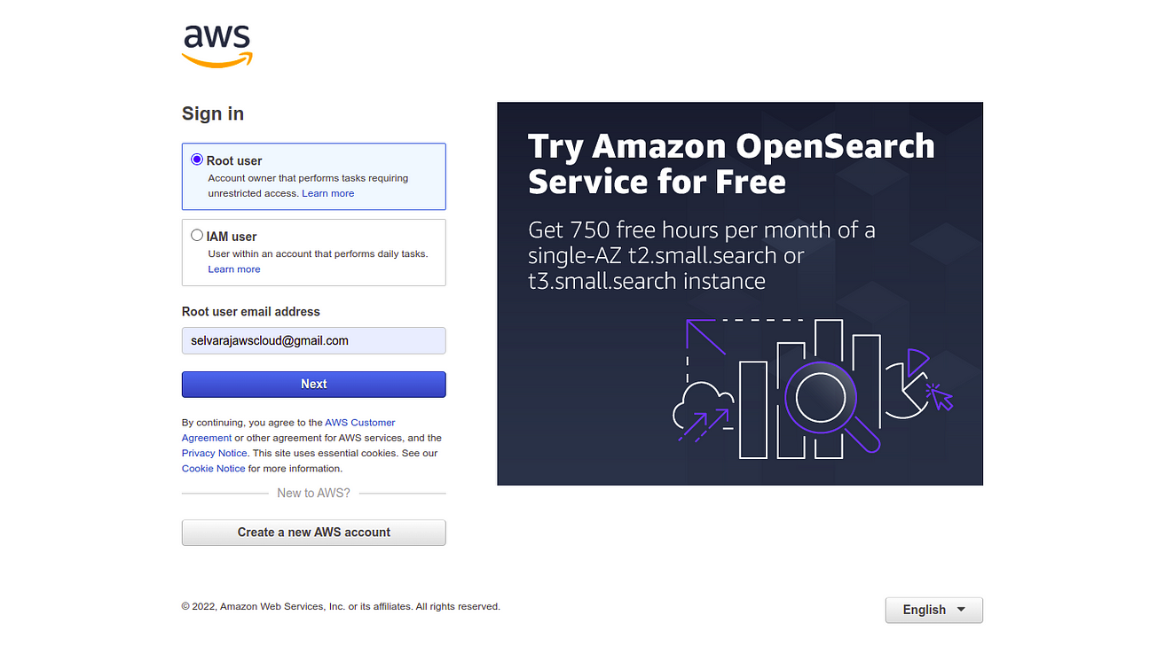

Sign in of AWS

If presented with a CAPTCHA, enter the displayed code, and then click **Submit**.

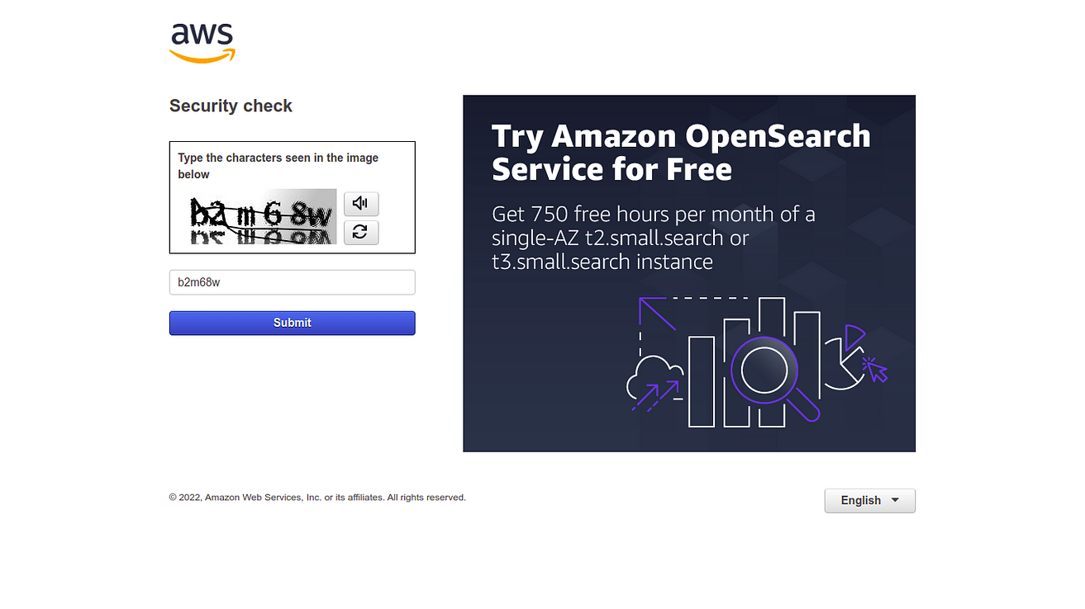

Sign in of AWS

Enter the root password and click **Sign In.**

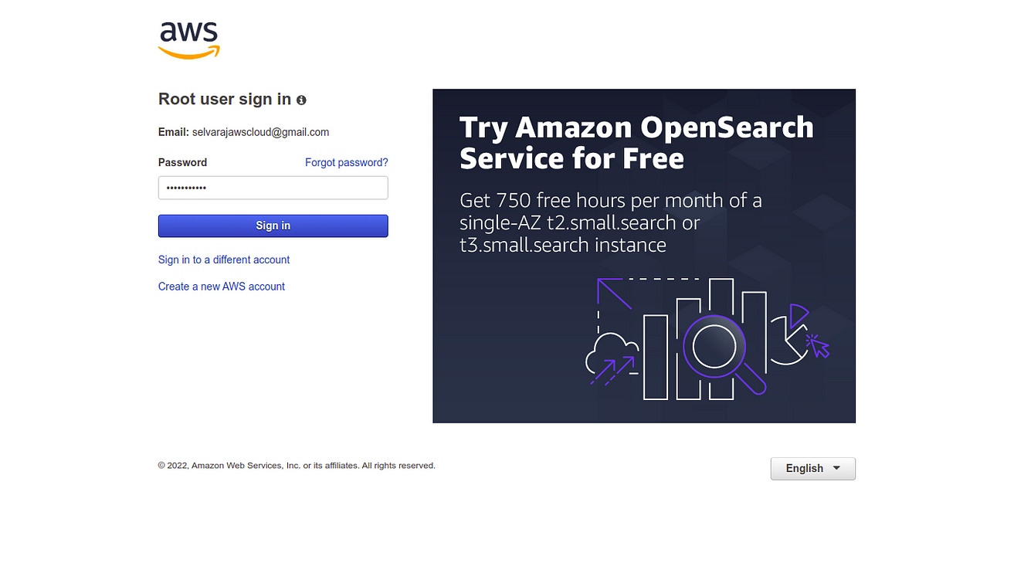

Sign in of AWS

Now, **Amazon Web Services** account has successfully logged in.

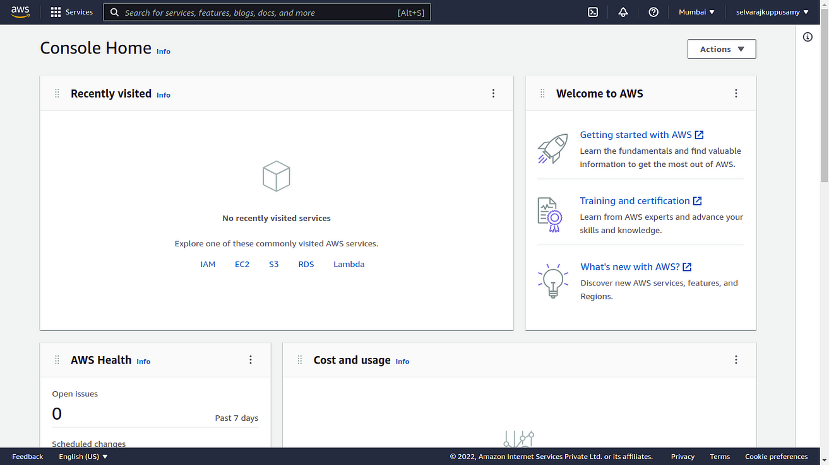

Amazon Web Services Page

Explore **All services**.

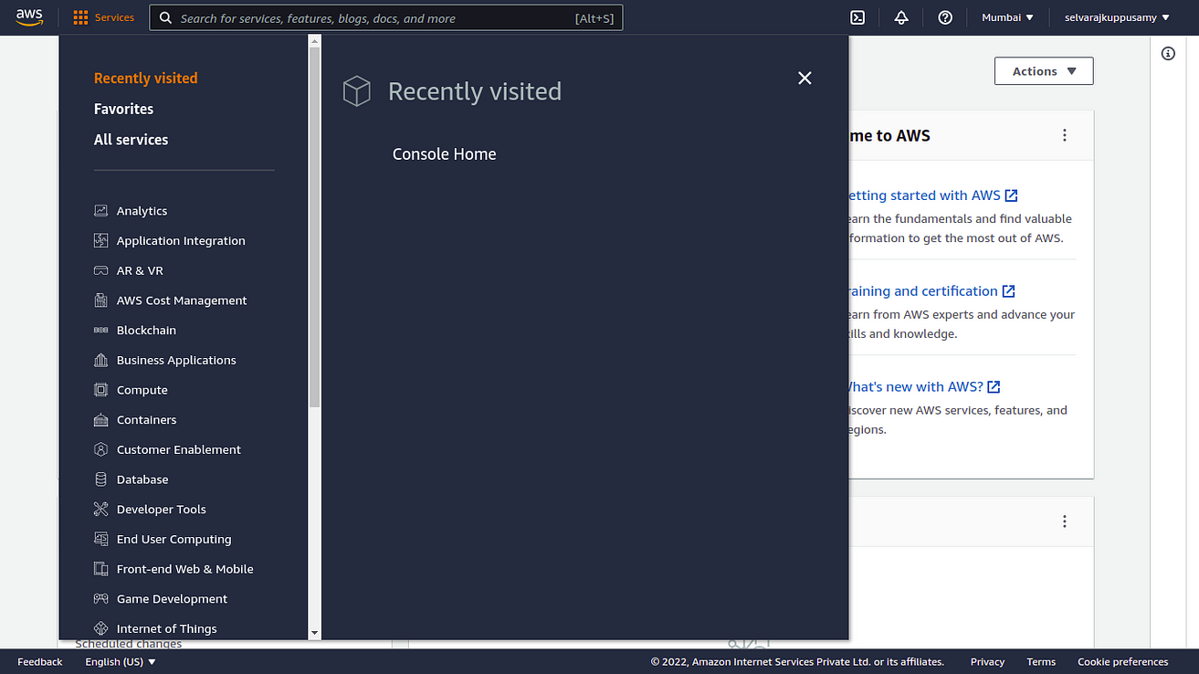

----------------------------- Thank you ---------------------------------------